|  |  |
| --- | --- |
|  | Information Technology Department - State Polytechnic of Malang  **Jobsheet-1: Web Server Installation and Basic HTML**  **Course: Web Programming / Web Design and Programming**  Instructor: Web Design and Programming Teaching Team  *August 2024* |

**Topic**

* Introduction to Basic Concepts of the Internet and Web
* Laragon Installation
* Introduction to HTML Fundamentals

**Objectives**

Students are expected to:

1. Understand the basic concepts of the Internet and the web
2. Install Laragon as web server
3. Be able to create static websites using HTML

**Introduction**

**What is the Internet ?**

* A large network of computers.
* Network of networks
* Operates based on the TCP/IP protocol

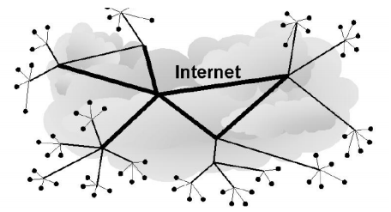

Picture 1. Internet Network

**What are the services provided by the Internet ?**

* *World Wide Web* (WWW): operates with the HTTP protocol
* E-mail: operates with *Post Office Protocol* (POP), *Simple Mail Transfer Protocol* (SMTP), *Internet Message Access Protocol* (IMAP)
* Chat : *Internet Relay Chat* (IRC)
* File Transfer: *File Transfer Protocol* (FTP)
* *Remote Access*: *telnet, Shell Secure* (SSH)
* VoIP (Voice over Internet Protocol)
* etc

**Website and Web Applications**

* Website (WWW)

A website is a collection of interlinked web pages that can be accessed through a homepage using a browser.

For example, when accessing the website at www.polinema.ac.id, the homepage will appear as follows.

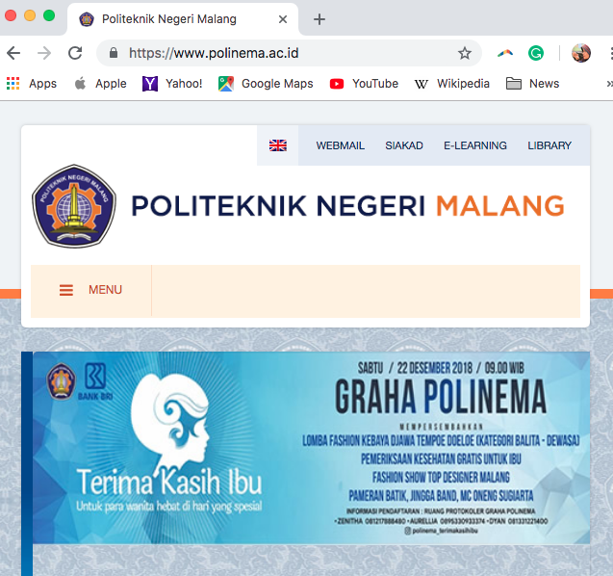

Picture 2. Homepage

Meanwhile, a web page is a part of the homepage that appears as a menu or link where, when clicked, will open a new page with information different from the homepage.

* *Static Web Statis vs Dynamic Web*

**Static Web** is a website where users cannot directly change the content of the web using a browser. The interaction between the user and the server is limited to processing links. These web pages do not have a database. The data and information on a static website do not change unless its syntax is altered. The web document sent to the client will be the same as what is on the web server.

**Dynamic Web** is a website where the interaction between the user and the server is very complex. A person can change the content of certain pages using a browser. Requests from users can be processed by the server and then displayed with different contents according to its program flow. These web pages are connected to a database, so a dynamic website will have different information and data depending on the input provided by the client. The document received by the client will be different from the document on the server.

**How does a website work ?**

1. When user enters the URL in the browser

https://www.google.com

1. The browser will translate the URL into an IP address and connect to the server via TCP on port 80 (HTTP service).

* In this case, we use the 'ping' command in CMD as an example.
* 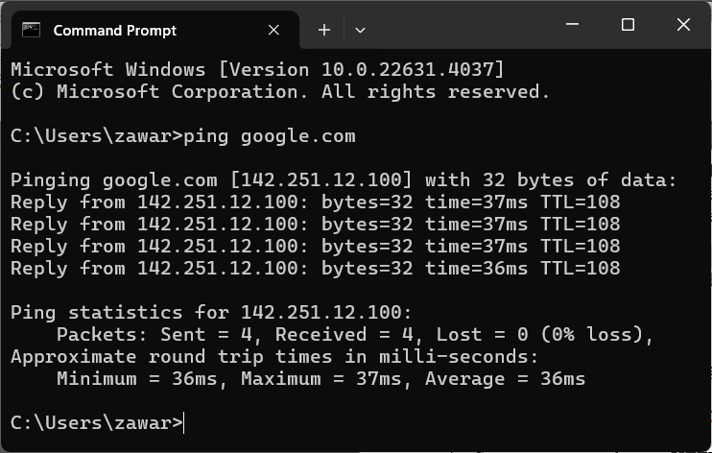

1. Through the established connection, the browser sends a GET request (HTTP request)

* GET/HTTP/1.1

1. The server responds with an HTTP response (including the header and the requested file in the body). The MIME type is also included to inform the browser about the file type (HTML, text, image, etc.)

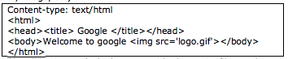

Picture 3. MIME Type

1. Files within the webpage, such as images, are not sent with the main file, so the browser must make additional requests to retrieve all the files on the webpage..

* GET /logo.gif HTTP/1.0

1. The browser will render the content to be displayed to the user in the browser..
2. HTTP connections do not remain continuous; once a file is downloaded, the connection is terminated.

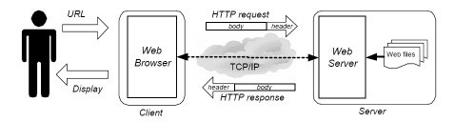

Picture 4. HTTP Request and Response

***Hypertext Markup Language* (HTML)**

HyperText Markup Language (HTML) is a language used to create web pages, where formatting is done using simple hypertext written in ASCII format to produce an integrated visual display. HTML is an internet standard defined and regulated by the World Wide Web Consortium (W3C). HTML was created through a collaboration between Tim Berners-Lee and Robert Cailliau while they were working at CERN in 1989 (CERN is a high-energy physics research organization in Geneva).

HTML can be read on various platforms and is a flexible programming language that can be combined with other programming languages such as PHP, ASP, JSP, and JavaScript. Certain tags in HTML documents define how text is formatted, and there are also other tags that specify how to respond to user actions. For example, open the page www.google.com, right-click in the browser (Chrome), and select "inspect," which will display the browser's developer tools as shown in Figure 5.

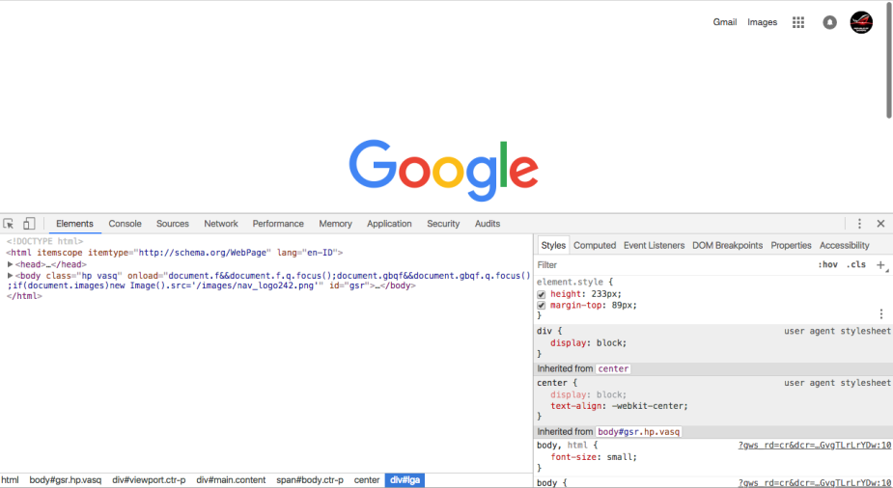

Picture 5**.** *Inspect Element*

In the first line, there is the text <!DOCTYPE HTML>, which indicates that the document you are viewing is an HTML document. On the second line, there is also the <HTML> tag, which further signifies that the code written within it is HTML code.

**Practical Section 1. Laragon Installation**

|  |  |
| --- | --- |
| **Steps** | **Description** |
| 1 | Download Laragon that matches your operating system from the link <https://laragon.org/download/>. |
| 2 | Install the Laragon that you downloaded in step 1. |
| 3 | Open your browser, type localhost, and run it.  Record the results (question No. 1). Include a screenshot of the display and provide an explanation. Please provide your answer below. |
| 4 | After completing the Laragon installation, proceed to Practical Section 2: Starting HTML. |

HTML is the standard format used to create web page documents. An HTML document has paired syntax called TAGs that are used to apply the desired effects. Generally, the format of a TAG is as follows:

<TAG> Text to be formatted </TAG>

Opening Tag Closing Tag

**Basic Structure of an HTML Page**

Every HTML document must start with the <html> tag and end with its complement, the </html> tag. An HTML document also includes three pairs of tags:

* + <head> and </head>: Used to declare information about the HTML document.
  + <title> and </title>: Used to add the title in the browser's title bar.
  + <body> and </body>: Used to enclose all the text on the HTML page.

In HTML5, the structure is more concise, as shown below:

|  |
| --- |
| <!DOCTYPE html>  <html lang="en">    <head>      <!-- This is a comment line, it is not processed. -->      <title>Document Title in HTML5</title>    </head>    <body>      This is body content    </body>  </html> |

**Practical Section 2: Starting HTML**

|  |  |
| --- | --- |
| **Steps** | **Description** |
| 1 | Open the Laragon folder in the directory where you installed Laragon. Navigate to the directory C:\laragon\www, and then create a new folder named dasarWeb. |
| 2 | Next, open your text editor, create a new file named hello.html, and save it in the dasarWeb directory that you just created. |
|  |  |
| 3 | Open your browser and type the following address: localhost/dasarWeb/hello.html. |
| 4 | Observe what appears in the browser. |
| 5 | Record your observations (question No. 2) and write your answer below.    Answer :  I have created a file called hello.html in the dasarWeb folder. When opened in a browser, the page displays the text “Hello World!” on the first line, followed by “Welcome to my first HTML Page.” on the second line, with the word first in bold. The browser tab title displays MY First Html Document. |
| 6 | Remove the <br> tag from the code, observe the difference, and describe below what the function of the <br> tag is. (question No. 3) Write your answer below.  Aswer:  The <br> tag function is used to create a new line in the text, like pressing Enter, without adding space between paragraphs. |

**Practical Section 3: Text Formatting**

HTML provides a variety of elements that can be used for text formatting.

* *Heading*

A heading is one of the essential elements in an HTML document. A heading is defined using the <h***n***> tag and is closed with the </h***n***> tag, where ***n*** represents the type, with values ranging from 1 to 6.

|  |  |
| --- | --- |
| **Steps** | **Description** |
| 1 | Create a file named heading.html and save it in the dasarWeb folder that you created in Practical Section 2. |
| 2 | Type the following code into heading.html |
|  |  |
| 3 | Open your browser and type the following address: localhost/dasarWeb/heading.html. |
| 4 | Observe what appears in the browser. |
| 5 | Record your observations (question No. 4) and write your answer below.    Answer:  The heading.html file displays six headings ranging from <h1> to <h6> with text sizes decreasing from the largest (h1) to the smallest (h6). Headings are used to title or emphasize sections on a web page. |
| 6 | Add the align attribute within the heading tag as shown below and save the file as headingAlign.html. |
| 7 |  |
| 8 | Open your browser and type the following address: localhost/dasarWeb/headingAlign.html. |
| 9 | Observe what appears in the browser. |
| 10 | Record your observations (question No. 5) and write your answer below.    Answer:  The headingAlign.html file displays headings with different sizes (h1–h6) while showing the function of the align attribute. Heading 1 is right-aligned, Heading 2 is left-aligned, Heading 3 is centered, while Headings 4 to 6 follow the default position (left-aligned). |

* Paragraph

Like regular text, an HTML document can consist of a collection of paragraphs. In the context of HTML, a paragraph is represented by the <p> tag. The <p> tag is actually a paired tag, although in practice, the closing tag is often omitted.

|  |  |
| --- | --- |
| **Steps** | **Description** |
| 1 | Buat sebuah file bernama paragraf.html dan simpan file tersebut di dalam folder dasarWeb yang telah dibuat pada Praktikum 2. |
| 2 | Ketikkan kode di bawah ini dalam paragraf.html |
| 3 | <!DOCTYPE html>  <html lang="en">    <body>      <p>        First paragraph      </p>      <p>        This is the second paragraph      </p>      <p>        And this is the third paragraph      </p>    </body>  </html> |
| 4 | Open your browser and type the following address:  localhost/dasarWeb/paragraf.html. |
| 5 | Observe what appears in the browser. |
| 6 | Record your observations (question No. 6) and write your answer below.    Answer:  The paragraph.html file displays three paragraphs of text using the <p> tag. Each paragraph appears on a separate line with automatic spacing between paragraphs, unlike the use of <br>, which only moves to a new line without additional spacing. |
| 7 | To adjust the paragraph alignment, use the align attribute within the paragraph tag. |
| 8 | Add the align attribute in the paragraph tag as shown below and save the file as paragrafAlign.html. |
| 9 | <!DOCTYPE html>  <html lang="en">    <head>      <title>        Manage Paragraph      </title>    </head>    <body>        <p align="right">          First Paragraph        </p>        <p align="center">          This is the second paragraph        </p>        <p align="left">          And this is the third paragraph        </p>    </body>  </html> |
| 10 | Open your browser and type the following address: localhost/dasarWeb/paragrafAlign.html. |
| 11 | Observe what appears in the browser. |
| 12 | Record your observations (question No. 7) and write your answer below.    Answer:  The paragraph.html file displays three paragraphs with different text positions using the align attribute. The first paragraph is right-aligned, the second paragraph is centered, and the third paragraph is left-aligned. This shows that the align attribute in <p> functions to set the text alignment within a paragraph. |

* Font

HTML provides several elements that can be used to manage fonts, such as **bold**, *italic*, underline, and many more. Additionally, this section will explain how to print tags. As you may know, the <p> tag in a document is automatically interpreted as a paragraph. However, to display the <p> character on the screen, we need to use entity names.

For example, the < character is represented by the entity name &lt, and the > character is represented by &gt.

**Practical Section 4 : Font**

|  |  |
| --- | --- |
| **Steps** | **Description** |
| 1 | Create a file named font.html and save it in the dasarWeb folder that you created in Practical Section 2. |
| 2 | Type the following code into font.html: |
| 3 |  |
| 4 | Open your browser and type the following address: localhost/dasarWeb/font.html. |
| 5 | Observe what appears in the browser. |
| 6 | Record your observations (question No. 8) and write your answer below.    Answer:  The font.html file displays examples of the use of various text formatting tags:   * <b> and <strong> → bold text. * <i> dan <em> → italic text. * <u> → underline. * <s> → striking out text. |

* Special Characters

In HTML, we can also display special characters by using entity names. The table below shows some types of special characters that can be used along with their entity names.

|  |  |  |
| --- | --- | --- |
| **Character** | **Description** | **Special Characters** |
| ¢ | Cent | &cent; |
| £ | Pound | &pound; |
| ¥ | Yen | &yen; |
| € | Euro | &euro; |
| © | Copyright | &copy; |
| ® | Registered | &reg; |
| ™ | Trademark | &trade; |

**Practical Section 5: Special Characters**

|  |  |
| --- | --- |
| **Steps** | **Description** |
| 1 | Create a file named karakter.html and save it in the dasarWeb folder that you created in Practical Section 2. |
| 2 | Type the following code into karakter.html: |
| 3 |  |
| 4 | Open your browser and type the following address: localhost/dasarWeb/karakter.html. |
| 5 | Observe what appears in the browser. |
| 6 | Record your observations (question No. 9) and write your answer below.    Answer:  The character.html file displays various special symbols using HTML Entities. These entities are used to display characters that are not available on the keyboard or that have special meanings in HTML, such as &pound; for £, &euro; for €, &copy; for ©, &reg; for ®, and &trade; for ™. |

**Practical Section 6: Horizontal Line**

In HTML, a horizontal line is represented by the <hr> tag. Although most browsers render this element with slightly different visualizations, it essentially represents a horizontal line.

|  |  |
| --- | --- |
| **Steps** | **Description** |
| 1 | Buat sebuah file bernama garishorizontal.html dan simpan file tersebut di dalam folder dasarWeb yang telah dibuat pada Praktikum 2. |
| 2 | Ketikkan kode di bawah ini dalam garishorizontal.html |
| 3 | <!DOCTYPE html>  <html lang="en">    <head>      <title>        Create Horizontal Line      </title>    </head>    <body>      UNDANG-UNDANG DASAR NEGARA REPUBLIK INDONESIA TAHUN 1945 <hr>      PEMBUKAAN <br>      Bahwa sesungguhnya kemerdekaan itu ialah hak segala bangsa dan oleh sebab itu, <br>      maka penjajahan di atas dunia harus dihapuskan, karena tidak sesuai dengan peri-kemanusiaan dan peri-keadilan. <hr>      Dan perjuangan pergerakan kemerdekaan Indonesia <br>      telah sampailah kepada saat yang membahagiakan dengan selamat sentausa <br>      mengantarkan rakyat Indonesia ke depan pintu gerbang kemerdekaan Negara Indonesia <br>      yang merdeka, bersatu, berdaulat, adil dan makmur. <hr>      Atas berkat rakhmat Allah yang maha kuasa dan dengan didorongkan oleh keinginan luhur <br>      supaya berkehidupan kebangsaan yang bebas, <br>      maka rakyat Indonesai menyatakan dengan ini kemerdekaannya. <hr>      Kemudian dari pada itu <br>      untuk membentuk suatu Pemerintah Negara Indonesia <br>      yang melindungi segenap bangsa Indonesia dan seluruh tumpah darah Indonesia <br>      dan untuk memajukan kesejahteraan umum, mencerdaskan kehidupan bangsa <br>      dan ikut melaksanakan ketertiban dunia yang berdasarkan kemerdekaan, perdamaian abadi dan keadilan sosial, <br>      maka disusunlah Kemerdekaan Kebangsaan Indonesia itu dalam suatu susunan Negara Republik Indonesia, <br>      yang berkedaulatan rakyat dengan berdasar kepada: <br>      Ketuhanan Yang Maha Esa, <br>      Kemanusiaan yang adil dan beradab, <br>      persatuan Indonesia <br>      dan kerakyatan yang dipimpin oleh hikmat kebijaksanaan dalam permusyawaratan/perwakilan, <br>      serta dengan mewujudkan suatu keadilan sosial bagi seluruh rakyat Indonesia.    </body>  </html> |
| 4 | Open your browser and type the following address:  localhost/dasarWeb/garishorizontal.html. |
| 5 | Observe what appears in the browser. |
| 6 | Record your observations (question No. 10) and write your answer below.    Answer:  The horizontalLine.html file displays text with separator lines using the <hr> tag. Horizontal lines serve to separate content or sections of text to make it more structured and easier to read. On this page, <hr> is used to separate the title, the paragraph stating independence, and the following explanatory section. |

**Practical Section 7: Using List**

HTML supports lists in the form of ordered, unordered, and definition lists. For each of these types, there are list items represented by the <li> and </li> tags, which indicate the individual items within the list.

|  |  |
| --- | --- |
| **Steps** | **Description** |
| 1 | Create a file named list.html and save it in the dasarWeb folder that you created in Practical Section 2. |
| 2 | Type the following code into list.html: |
| 3 |  |
| 4 | Open your browser and type the following address: localhost/dasarWeb/list.html. |
| 5 | Observe what appears in the browser. |
| 6 | Record your observations (question No. 11) and write your answer below.    Answer:   1. Ordered List (<ol>): A numbered list: “1. one”, “2. two”, and “3. three”. 2. Unordered List (<ul>): A list with points “• one”, “• two”, and “• three”. 3. List of Definitions (<dl>): Pairs of terms and descriptions, such as “one” with “one one” and “one two,” and ‘two’ with “two two.” |

**Practical Section 8: Coloring**

To set a background color, HTML provides the bgcolor attribute in the <body> tag. This attribute can be filled with a color name (e.g., red) or a hexadecimal code (e.g., #FFFFFF).

For certain other elements, the color attribute is available to apply coloring. Similar to bgcolor, the value of this attribute can also be a color name or a hexadecimal code.

|  |  |
| --- | --- |
| **Steps** | **Description** |
| 1 | Create a file named warna.html and save it in the dasarWeb folder that you created in Practical Section 2. |
| 2 | Type the following code into warna.html |
| 3 |  |
| 4 | Open your browser and type the following address: localhost/dasarWeb/warna.html. |
| 5 | Observe what appears in the browser. |
| 6 | Record your observations (question No. 12) and write your answer below.    Answer:  The web page displays a light blue background. Heading 3 is centered, then the first line of text is red, the second line is also red but uses hex values. |

**Practical Section 9: Working with Images**

An HTML document can contain graphics in addition to text.HTML offers the <img> tag, which is supported by several attributes, for this purpose.

|  |  |
| --- | --- |
| **Steps** | **Description** |
| 1 | Place an image in the dasarWeb folder with any size and name the image bunga2. If the image is in JPG format, the name should be bunga2.jpg (the file can be in a format other than JPG). |
| 2 | Create a new folder inside the dasarWeb folder and name it img. |
| 3 | Place a different image with any size in the img folder and name it bunga1. If the file is in JPG format, the name should be bunga1.jpg (the file can be in a format other than JPG). |
| 4 | Create a file named gambar.html and save it in the dasarWeb folder that you created in Practical Section 2. |
| 5 | Type the following code into gambar.html: |
| 6 |  |
| 7 | Open your browser and type the following address: localhost/dasarWeb/warna.html. |
| 8 | Observe what appears in the browser. |
| 9 | Record your observations on the two methods of displaying images on the webpage (question No. 13) and write your answer below.    Answer:  The code demonstrates how to insert images using relative paths and absolute paths. The first part uses src="flower2.jpg". This is a relative path, which means the browser will search for the flower2.jpg image file in the same folder as the image.html file. The second part uses src="../webbase/img/flower1.jpg". This is an absolute path, indicating the location of the bunga1.jpg image from the parent directory (..), then into the dasarWeb folder, and then img. The align="right" attribute is used to place the image on the right side. |

**Practical Section 10 : Link**

* A link in HTML is called a Hyperlink.
* A Hyperlink is an element, text, or an image that can be clicked to navigate to another document.
* The browser will highlight text or images identified as links with a color and/or underline to indicate that it is a hypertext link (hyperlink or link).
* The syntax for a link in HTML:

The <a> (Anchor) tag is used to create a link to another document by adding the href attribute, which defines the link's destination.

<a href="url">linked text</a>

* The href attribute provides the link's destination address.
* The linked text is the text that will appear on the webpage containing the link, and when clicked, it will navigate to the address specified in the href attribute.
* Example: <a href="https://polinema.ac.id">Click to go to Polinema</a>
* Types of Links

1. **Relative Link**

A local link that points to a location within the same website, specified by a URL (without <https://www>.).

1. **Absolute Link**

Used to create a link to a webpage on another website on the internet.

1. **Link within the Same Document**

This type of link is used for long documents that, when displayed in a web browser, require the user to scroll repeatedly. Navigation within the document can be simplified by creating links between sections, with each section being marked with a name. This allows a link to be placed elsewhere in the document to jump to that specific section.

Steps to name a section within a document:

* Place the cursor at the line or text that will mark the beginning of the section.
* Insert the name of the section with: <a name="section name">.
* Creating a link to the same document can be done similarly to absolute or relative links, but the document's name in the link is replaced with the section name, prefixed by #. Example: <a href="#section name">Section about link</a>.

Practical Steps:

|  |  |
| --- | --- |
| **Steps** | **Description** |
| 1 | Create a file named macamLink.html and save it in the dasarWeb folder that you created in Practical Section 2. |
| 2 | Type the following code into macamLink.html: |
| 3 |  |
| 4 | Open your browser and type the following address: localhost/dasarWeb/macamLink.html. |
| 5 | Observe what appears in the browser and how each link functions. |
| 6 | Record your observations (question No. 14) and write your answer below.        Answer:   1. Relative Links: Use href that refers to local files, such as image.html. This is useful for linking pages within a single site. 2. Absolute Links: Use the full URL, such as http://www.google.com, to link to external sites. 3. New Window Link: Similar to an absolute link, but with the target="_blank" attribute that forces the browser to open the link in a new tab or window. 4. Email Link: Utilizes the mailto: scheme to automatically open the user's email application, facilitating message sending. |

**Practical Task Section 10: Links**

Create a webpage and name it tugasLink.html.

Display an image that contains a link to https://www.google.com

**Practical Section 11 : Table and Table Formatting**

In a webpage, tables serve as a framework for organizing the content components, ensuring that the content is arranged neatly within the webpage.

Here is an example of a table structure design:

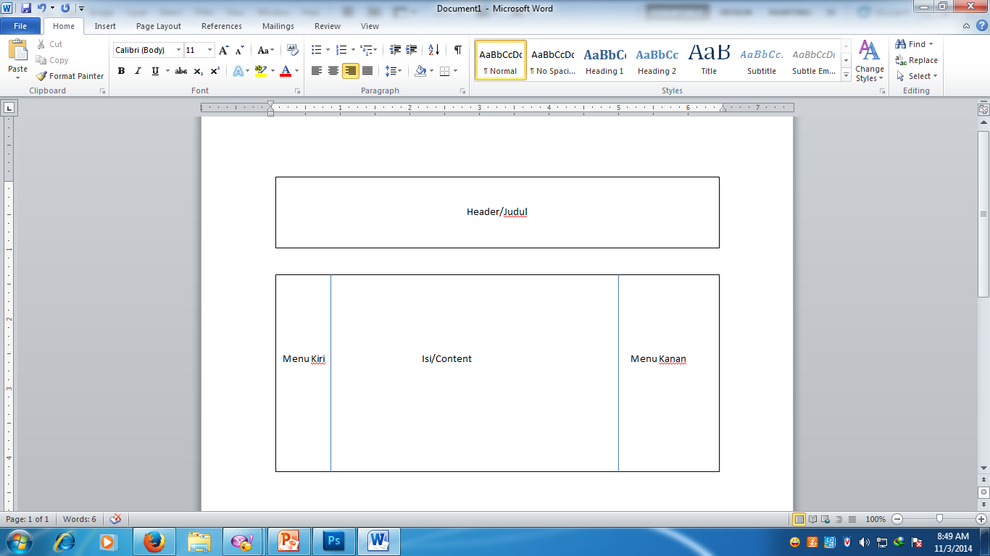

Picture 6. Example of a Table in a Web Page

* Creating Table

Creating a table in HTML begins with the <table> tag and ends with the </table> tag.

* <table>: This tag informs the browser that it is a table.
* <tr>: Table Row tag, used to create a row within the table.
* <td>: Table Data tag, used to place the data that you want to include in the table. The <td> can also be understood as a column.

The structure of a table is illustrated in Figure 7.

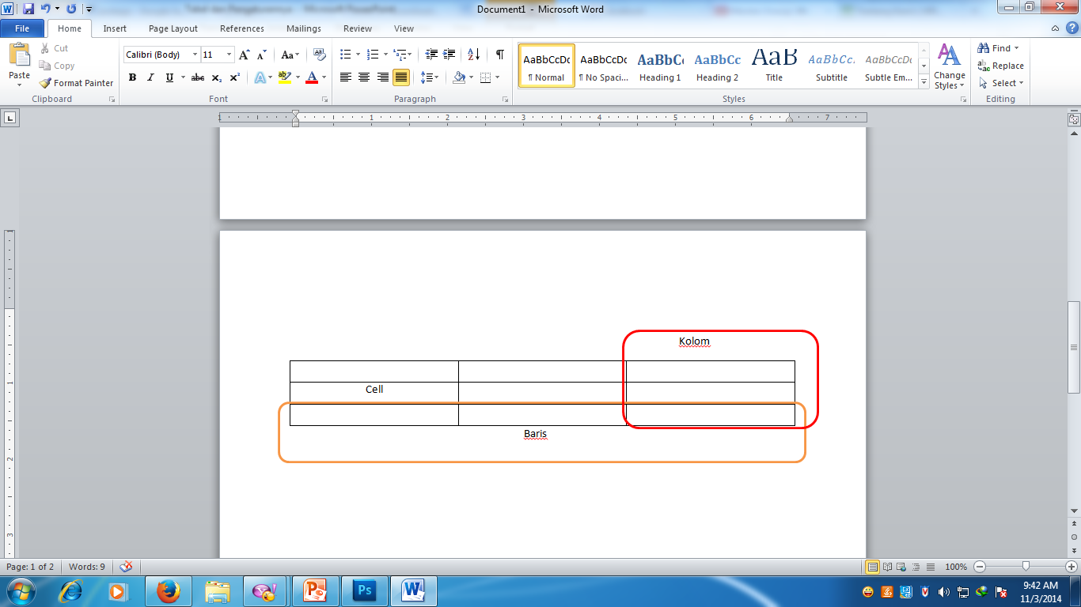

Figure 7. Table Structure

The syntax for creating a table is as follows:

|  |
| --- |
| <table attribue="value">  <thead>    <tr>        <th attribue="value"> Header Content </th>        <th attribue="value"> Header Content </th>    </tr>  </thead>  <tbody>    <tr>        <td attribue="value"> Body Content </td>        <td attribue="value"> Body Content </td>    </tr>  </tbody>  </table> |

* Table Configuration

Here are the attributes that can be used for table and row configuration.

* Attributes for Tabel

|  |  |
| --- | --- |
| **Attribute** | **Description** |
| align | Used to align the table to the left, center, right, or justify it. |
| border | Used to set the thickness of the border lines between cells in the table. |
| width | Used to specify the width of the table; you can set the table width using a percentage (%). |
| cellspacing | Used to define the space (padding) between cells and between the cells and the border. |
| cellpadding | Defines the space (padding) between the content of the cell and the cell's border. |
| bgcolor | Specifies the background color for all cells in the table. |
| bordercolor | Used to set the color of the border lines. |

* Attributes for Table Row

|  |  |
| --- | --- |
| **Attribute** | **Description** |
| align | Used to align the table to the left, center, right, or justify it. |
| valign | Used for vertical alignment; valign can be set to values such as top (top of the page), center (middle of the page), bottom (bottom of the page), or baseline (standard). |
| bgcolor | Indicates the background color for the row. |

* Merger Cell

Table cell merging can be achieved using the following attributes:

* + Rowspan: Used to merge cells across multiple rows. For example, to merge three rows, you would set rowspan="3".
  + Colspan: Used to merge cells across multiple columns. For example, to merge three columns, you would set colspan="3".

**Practical Steps:**

|  |  |
| --- | --- |
| **Steps** | **Description** |
| 1 | Create a file named buatTabel.html and save it in the dasarWeb folder that you created in Practical Section 2. |
| 2 | Type the following code into buatTabel.html |
| 3 |  |
| 4 | Open your browser and type the following address: localhost/dasarWeb/buatTabel.html. |
| 5 | Observe what appears in the browser. |
| 6 | Record your observations (question No. 15) and write your answer below.    Answer:  The web page displays a simple table. The table has only one row (<tr>) containing two columns (<td>) with the text “This is the first row of the first column” and “This is the first row of the second column.” |
| 7 | Add the attribute border="1" to the <table> tag. Save the file and run it again in the browser at localhost/dasarWeb/buatTabel.html. |
| 8 | Observe what changes appear on the screen. |
| 9 | Record your observations (question No. 16) and write your answer below.    Answer:  The border="1" attribute gives the table a border that is 1 pixel thick. So, on the web page, the table will look clearer, with boxes, unlike the previous one where only the text was visible. |
| 10 | Add one row to the table you previously created and add one column within it. |
| 11 | Write down the code for the modified buatTabel.html. (question No. 17) and write your answer below.  Code: <tr>                    <td>Ini baris kedua kolom pertama</td>            </tr>  Answer:  Add a row and column by adding the code above after <td>. |
| 12 | From the code you modified in question No. 17, add the attributes height="100%" and width="40%" to the <table> tag. |
| 13 | Save your work, then run it again in the browser at localhost/dasarWeb/buatTabel.html. |
| 14 | Note the changes here (question No. 18) and write your answer below    Answer:  After adding the height and width attributes with specific values, the height and width will adjust to the specified values. |
| 15 | From the code you modified in step 12, remove the % symbol from height and width, so it becomes height="100" and width="40". |
| 16 | Save your work, then run it again in the browser at localhost/dasarWeb/buatTabel.html. |
| 17 | What do you understand about the difference between using and omitting % in the code? Note your understanding here (question No. 19) and write your answer below.    Answer:   * Percentage (%): Relative. The size of the element will adjust proportionally to the size of its parent element. This makes the design flexible and responsive to changes in screen size. * Percentage-Free Values (%): Absolute. The size of the element will remain consistent in pixels, regardless of the size of its parent element. This is suitable for elements that require precise, unchanging dimensions. |
| 18 | From the code you modified in step 15, add the attribute cellpadding="20". |
| 19 | Save your work, then run it again in the browser at localhost/dasarWeb/buatTabel.html. |
| 20 | Note the changes here (question No. 20) and write your answer below.    Answer:  cellpadding=“20” provides a distance of 20 pixels between the cell content and its border, making the table appear less crowded. |
| 21 | From the code you modified in step 18, add the attribute cellspacing="5". |
| 22 | Save your work, then run it again in the browser at localhost/dasarWeb/buatTabel.html. |
| 23 | Note the changes here (question No. 21) and write your answer below.    Answer:  cellspacing=“5” creates a 5-pixel gap between each table cell, preventing the table cells from sticking together and giving a neater and clearer appearance. |
| 24 | From the code you modified in step 21, in the code used to set column 1 of row 1, add the attribute align="right", so the code in that section becomes <td align="right">. |
| 25 | Save your work, then run it again in the browser at localhost/dasarWeb/buatTabel.html. |
| 26 | Note your observations here (question No. 22) and write your answer below    Answer:  Make the first row of the first column be on the right/right-aligned |
| 27 | From the code you modified in step 24, add % to height and width, so it becomes height="100%" and width="40%". |
| 28 | Next, in the code used to set column 1 of row 1, add the attribute valign="bottom", so the code in that section becomes <td align="right" valign="bottom">. |
| 29 | Save your work, then run it again in the browser at localhost/dasarWeb/buatTabel.html. |
| 30 | Note your observations here (question No. 23) and write your answer below.    Answer:  Valign=“bottom” makes the text appear at the bottom |
| 31 | From the code in step 28, add font settings to the content of the first row, first column, by adding the <font> tag inside the <td> tag.  You can see this in step 32. |
| 32 |  |
| 33 | Save your work, then run it again in the browser at localhost/dasarWeb/buatTabel.html. |
| 33 | Note your observations here (question No. 24) and write your answer below.    Answer:  The text between the <font> tags will be displayed using the Courier font. |
| 34 | Change the text color of “ini baris pertama kolom pertama” to red and set the size to 15. |
| 35 | Write the modified code from step 34 in the buatTabel.html file here (question No. 25). And write your answer below    Code: color=”red” size=”15”  Answer:  The text in the first row of the first column changes to red and the size becomes 15, as per question no. 34. |
| 36 | After completing step 35 in the buatTabel.html code, add the attribute colspan="2" to the second row, first column, so that the <table> tag results in a code snippet similar to what is shown in step 37. |
| 37 |  |
| 38 | From the code you completed in step 36, add one more column to the first row, so that the display will look like what is shown in step 39. |
| 39 | (question No 26) Write down your code here  Code: <td>tambah 1 kolom</td> |
| 40 | Next, add one more column to the second row so that the display will look like what is shown in step 41. |
| 41 | (question No 27) Write down your code here    Code:  <td>Ini juga tambah 1 kolom lagi</td>  <td colspan="2">Ini sekarang menjadi gabungan 2 kolom</td> |
| 42 | Add the attribute rowspan="2" to the second row, first column. Save your work, run it in the browser, and observe the changes. |
| 43 | Note your observations here (question No. 28) and write your answer below.    Answer:  No changes, because the empty column is in row 2 and there are no empty columns in the first row |
| 44 | From the code in step 42, remove rowspan="2" from the second row, first column. |
| 45 | Then add rowspan="2" to the first row, first column so that the code will look like what is shown in step 46. |
| 46 |  |
| 47 | Save your work and run it in your browser. Observe the difference between the code in step 42 and step 45. |
| 48 | Note your observations here (question No. 29) and write your answer below.    Answer:  The difference between the code in step 42 and the code in step 45 is that it combines or fills in rows with empty columns and corresponds to the code, which is 2. |

**Practical Section 12 : Working with Forms in HTML**

A form is a place for data input before being processed by the system. Examples include login forms, comment forms, user data forms, and more. The process of data input from a form will be discussed in PHP, MySQL, and JavaScript materials. The tag used to create a form is the <form> tag, which can contain elements like <input>, <textarea>, <option>, and <select>.

The form has attributes such as action and method. The action attribute specifies the URL that will be executed and receives all the input from the form. If action is not specified, the form data will be sent to the same URL as the webpage itself, while the method attribute contains the method used by the form to submit the data (GET/POST).

* **GET**: Information is sent along with the URL.
* **POST**: Information is sent separately from the URL.

Syntax :

|  |
| --- |
| <form action="url" method="GET|POST">    ...... form fields  </form> |

**INPUT Element**

The <input> element is used to define the input that will be provided by the user. This element has attributes such as name, size, type, value, and checked.

* The name attribute defines the name of the input control within the form.
* The size attribute defines the size of the text within the input control.
* The type attribute defines the different types of input controls.
* The value attribute defines the initial value, reset, or submit value.
* The checked attribute defines the selected option for radio or checkbox types.

This element does not have a closing tag and must be placed within a <form> element.

Syntax :

|  |
| --- |
| <input name="name" type="text" value="Name of .....">  <input name="name_val" size="number" type="checkbox" value="1" checked> |

Attributes type:

|  |  |
| --- | --- |
| **Type** | **Description** |
| button | <input type="button">: Defines a clickable button (usually used with a JavaScript script). |
| checkbox | <input type="checkbox">: Defines a checkbox. |
| color (HTML5) | <input type="color">: Defines a color picker. |
| date (HTML5) | <input type="date">: Defines a date picker (year, month, day with no time). |
| datetime-local (HTML5) | <input type="datetime-local">: Defines a date and time picker (year, month, day, time with no timezone). |
| email (HTML5) | <input type="email">: Defines an input area for an email address. |
| file | <input type="file">: Defines an area for selecting a file with a "Browse" button (for file uploads). |
| hidden | <input type="hidden">: Defines a hidden input field. |
| image | <input type="image">: Defines an image as a button. |
| month (HTML5) | <input type="month">: Defines a month and year picker (no timezone). |
| number (HTML5) | <input type="number">: Defines an area for entering a number. |
| password | <input type="password">: Defines an area for entering a password. |
| radio | <input type="radio">: Defines a radio button. |
| range (HTML5) | <input type="range">: Defines a range control (like a slider). |
| reset | <input type="reset">: Defines a reset button. |
| search (HTML5) | <input type="search">: Defines a text area for entering a search query. |
| submit | <input type="submit">: Defines a submit button. |
| tel (HTML5) | <input type="tel">: Defines a text area for entering a phone number. |
| text | <input type="text">: Default. Defines a single-line text area. |
| time (HTML5) | <input type="time">: Defines a time picker (no timezone). |
| url (HTML5) | <input type="url">: Defines an area for entering a URL. |
| week | <input type="week">: Defines a week and year picker (no timezone). |

**SELECT Element**

The <select> attribute is used to define selectable options in a form control. This element has attributes such as name, size, and multiple (which allows multiple selections). This element must be placed within a <form> element.

Syntax :

|  |
| --- |
| <select name="name" size="number" multiple>      ......  </select> |

**OPTION Element**

The <option> element defines the selectable options within a <select> menu. This element has attributes such as selected and value. The selected attribute indicates the default selected option, and the value attribute holds the value associated with the option element.

Syntax:

|  |
| --- |
| <select name="name" size="number">    <option value="value-1">Text 1</option>    <option value="value-2">Text 2</option>    <option value="value-3">Text 3</option>  </select> |

**TEXTAREA Element**

The <textarea> element functions as a form input control for entering multi-line text. This element has attributes such as name, cols, and rows. The name attribute defines the name of the input control for the <textarea> element, the cols attribute defines the number of visible columns in the textarea, and the rows attribute defines the number of visible rows in the textarea. This element must be placed within a <form> element.

Syntax:

|  |
| --- |
| <textarea name="name" rows="number" cols="number">    ...... text  </textarea> |

**Practical Steps:**

|  |  |
| --- | --- |
| **Steps** | **Description** |
| 1 | First, in this practical session, you will create a form with elements as shown in the picture: |
| 2 | Create a file named buatForm.html and save it in the dasarWeb folder that you created in Practical Section 2. |
| 3 | Type the following code into buatForm.html: |
| 4 |  |
| 5 | Save the file, then open your browser and type the following address: localhost/dasarWeb/buatForm.html. |
| 6 | Observe what appears in the browser. |
| 7 | Note your observations and understanding here (question No. 30) and write your answer below.    Answer:  The web page functions as a simple interactive form. At the top of the browser, the page title is displayed as “Creating Files.” On the page, there is a main title “FORM.”  This form contains several input elements that allow users to enter data. The first element is a text field named var1 that displays the placeholder text “Enter your name here” to guide users. Next, there is a question “Are you a student” accompanied by a checkbox to select.  Then, the form presents the question “How old are you” with three mutually exclusive radio buttons: 10-15, 16-20, and 21-25, where users can only select one of them.  At the bottom of the form, there are two action buttons. The “send” button sends the data entered by the user to the gambar.html file. Meanwhile, the “clear” button resets or deletes all data that has been entered, returning the form to its initial state. |
| 8 | Note your observations and understanding here (question No. 30) and write your answer below. Add a text input field to enter an address, placing it below the text input field for entering a name. Save the file, then run it in the browser at localhost/dasarWeb/buatForm.html. |
| 9 | Observe what changes in the display. |
| 10 | Record the code you added in step 7 here (question No. 31) and write your answer below.    Answer:  Additional text input for the address is created with the <input type="text"> tag. In this tag, the name="address" attribute serves to give a unique name to the input data so that it can be identified when the form is submitted. The size="30" attribute sets the visual width of the input field to 30 characters. Finally, the placeholder="Enter your address here." attribute displays guidance text in the field that automatically disappears when the user starts typing. |
| 11 | Add the following program code below the last radio button, above the submit and clear buttons. |
| 12 | Does the display in the browser look like the one shown below? (question No. 32).    **Write your answer here :**  Yes |
| 13 | From the code you modified in question No. 32, add a checkbox input that displays the option "I have a plane" and move the checkmark ✓ from the option "I have a bike" to the checkbox option "I have a plane". |
| 14 | Save your work, then run it again in the browser at localhost/dasarWeb/buatForm.html. |
| 15 | Write down here the code for the entire checkbox configuration, including the code for the checkbox you just added. (question No. 33). Write your answer below  Answer:  Code: <input type="checkbox" name="vehicle4" value="Plane" checked> I have a plane <br> |
| 16 | Add the program code from step 17 into the program code you modified in step 13. Place it below the checkbox configuration and above the button configuration. |
| 17 |  |
| 18 | Save your work, then run it again in the browser at localhost/dasarWeb/buatForm.html. |
| 19 | Note here what the code snippet in step 17 means (how it works). (question No. 34) Write your answer below.    Answer:  The code creates a selection box with three options: “Bulgaria,” “United Kingdom,” and “USA.” The attribute size="1" ensures that this selection box appears as a standard dropdown menu. By default, the “USA” option will be selected because of the selected attribute in the code line. |
| 19 | From the code you modified in step 17, add one more country option, "Indonesia," and set "Indonesia" as the default selected option. |
| 20 | Save your work, then run it again in the browser at localhost/dasarWeb/buatForm.html. |
| 20 | Note the changes here (question No. 35) and write your answer below.  Answer: Code: option value="ID" selected>Indonesia |
| 21 | From the code in step 17, change the value of size=1 to size=2. |
| 22 | Save your work, then run it again in the browser at localhost/dasarWeb/buatForm.html. |
| 23 | Note the changes here (question No. 36) and write your answer below.    Answer:  Atribut Size=2 akan membuat kotak pilihan tampil sebagai daftar yang dapat digulir atau scroll di mana dua opsi terlihat secara langsung pada satu waktu tanpa perlu diklik. Jika jumlah total opsi lebih dari dua, pengguna harus menggulir ke bawah untuk melihat pilihan sisanya. |
| 24 | From the code you modified in step 21, revert the value of size back to 1. |
| 25 | Save your work, then run it again in the browser at localhost/dasarWeb/buatForm.html. |
| 26 | From the code you modified in step 24, add a single text area to input a password using the <input> element with the type="password", so that the display will look like this: |
| 27 | Save your work, then run it again in the browser at localhost/dasarWeb/buatForm.html. |
| 28 | Record the code you added in step 26 here. (question No. 37) and write your answer below.  Answer:  Code: <b>Enter your private code</b>          <input type="text" name="password" size="30" placeholder=""><br><br>          <input type="submit" name="var5" value="send">          <input type="reset" name="var6" value="clear"> |
| 29 | From the code in step 28, add a text area for typing long comments using the <textarea> and </textarea> tags, so that the display will look like this: |
| 30 | Save your work, then run it again in the browser at localhost/dasarWeb/buatForm.html. |
| 31 | Please record the code you added in step 29 here (question No. 37). Write your answer here  Answer:  Code: <textarea name="var9" rows="5" cols="50">Fill this area</textarea> |
| 32 | Notice that the <form> tag includes the attribute method="POST". Run the form again in the browser at localhost/dasarWeb/buatForm.html, fill out the form, and then click the "Send" button. Observe the URL in the address bar of the page you are directed to after clicking the "Send" button. |
| 33 | Open the buatForm.html code again and change the method from POST to GET. Save the file, then run it again in the browser at localhost/dasarWeb/buatForm.html. Fill out the form and click the "Send" button. Observe the URL in the address bar of the page you are directed to after clicking the "Send" button.  Compare and note the differences between the GET and POST methods based on what you observe. |
| 34 | Note your observations here (question No. 38) and write your answer below.    Answer:  GET Method: Mengirim data dalam bentuk pasangan nama-nilai yang ditambahkan ke URL, untuk mengambil atau meminta data seperti pencarian.  POST Method: Mengirim data di dalam body, permintaan HTTP bukan di URL. Cocok untuk mengirimkan data yang akan membuat perubahan, seperti login, pendaftaran, atau pengiriman formulir. |

**References:**

1. Jason Beaird, *The Principles of Beautiful Web Design*
2. Rian Ariona, *Belajar HTML dan CSS (Tutorial Fundamental dalam mempelajari HTML dan CSS)*
3. Adi Hadisaputra, *HTML dan CSS Fundamental dari Akar menuju Daun*
4. John Duckett, *HTML and CSS: Design and Build Websites*

Nama : Moh. Rafael Abrari

NIM : 244107060039

Absen :13